Nepal College of information Technology
Imadol lalitpur
Unit Test Fall Semester 2005/2006

Program : BE Semester: II
Time : 2hrs Year : I
Engineering Math-III

Attempt all the questions

1. a. The necessary and sufficient condition for the vector valued fucntion of the scaler variable t to have a constant directio is
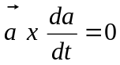 8
b. A particle is moving along the curve s=t³ + 1 , y = t² , z= 2t + 5, Find the components of iths velocity and accleration at t=1 in the dirction 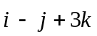. 7
2. a. Find the angle between the tangent planes to he surcace xlog z = y² -1 & x²y= 2-z at (1,1,1). 7
b. Let be a vector valued function which is continuous and differentiable, then show that div(curl 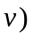=0. 8
3. a. Find 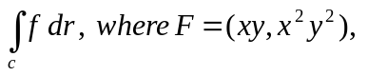C is the straignt line from (2,0) to (0,2). 7
b. Define transpose of a matrix. If A and B are matrices of specified order, prove that (AB)^{t} =B^{t}A^{t} . 8
Or
Show that 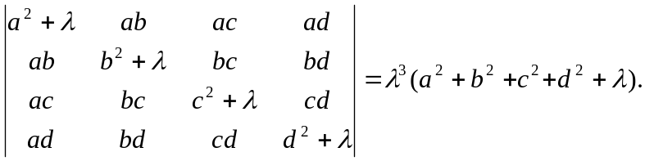

4. a. Define Inverse of a matrix. Find the inverse of
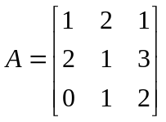 8
b. Solve by Gauss elimination method : 7
x-y+z=2
2x+3y+4z=20
4x+y-3z= -3

